This process works the same for all 3 tables
- preferred_frequency_schedules
- preferred_medication_doses
- preferred_medication_routes
Process to Load the Preferred Medication Frequency Schedules for a customer in SQL Database
- Have customer build Preferred Medication Frequency Schedules in Excel Spreadsheet: : preferred_frequency_schedules_import_template.xlsx
- Export Excel data to csv file (screen #1)
- Open ssms (sql server management studio)
  - Delete Table: preferred_frequency_schedules_import_template
    - ssms SQL: drop table dbo.preferred_frequency_schedules_import_template
  - In ssms Import csv file (screen #2)
    - Right click emar>>Tasks>>Import Flat File
    - Follow Screen #3 through #8 (Screen #6 change data type)
- In ssms run script: preferred_frequency_schedules_update_script.sql (Screen #9)
  - Select Option : @type_of_run varchar(6) = 'report';
  - This is a report that displays all the changes that will happen during the update (Screen #10)
- In ssms run script: preferred_frequency_schedules_update_script.sql (Screen #9)
  - Select Option : @type_of_run varchar(6) = 'update';
  - This display a count of records changes (screen #11)
  - Optionally running this again would return record counts of all 0 because updates have been completed
- Optional run step #4 again there should be no changes left to display in the report

Process to pre-populate Excel with existing customer data
- Open ssms (sql server management studio)
- Open Excel file: preferred_frequency_schedules_import_template.xlsx to the TAB: import_data
- Run sql query: change name as required or sort order as preferred
select *
from [dbo].[preferred_frequency_schedules_export_view] [pfsev]
where site_name = 'Middle-earth'
order by [drug_id]
- Right click on the results (Screen #13)
  - Select All
  - Select Copy
  - Paste into Excel under the existing header columns (Screen #13)

Screen #1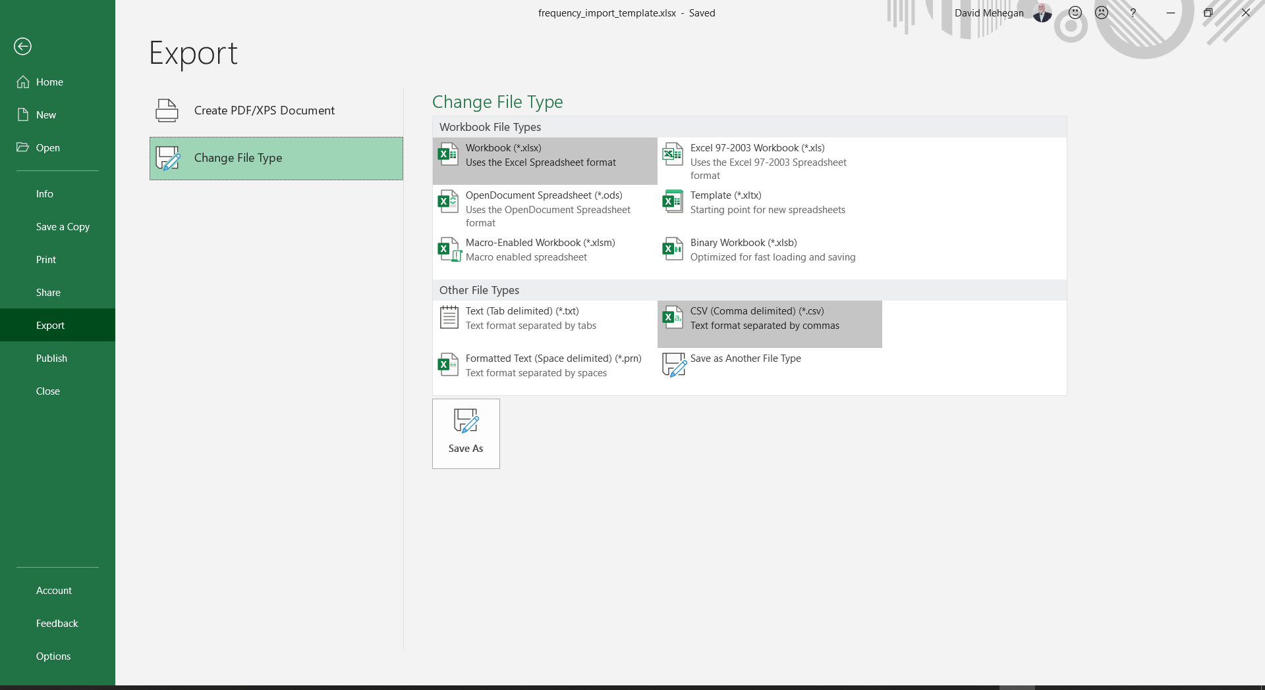

Screen #2
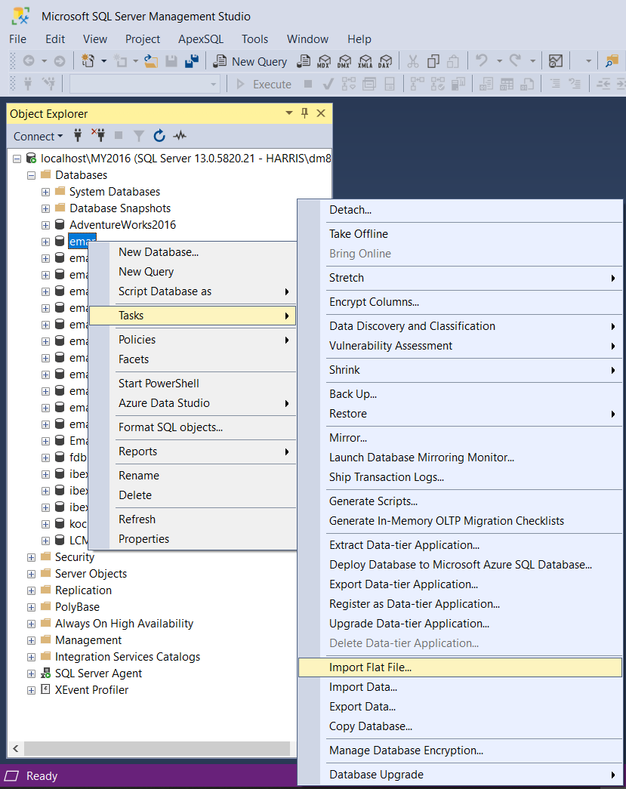
Screen #3
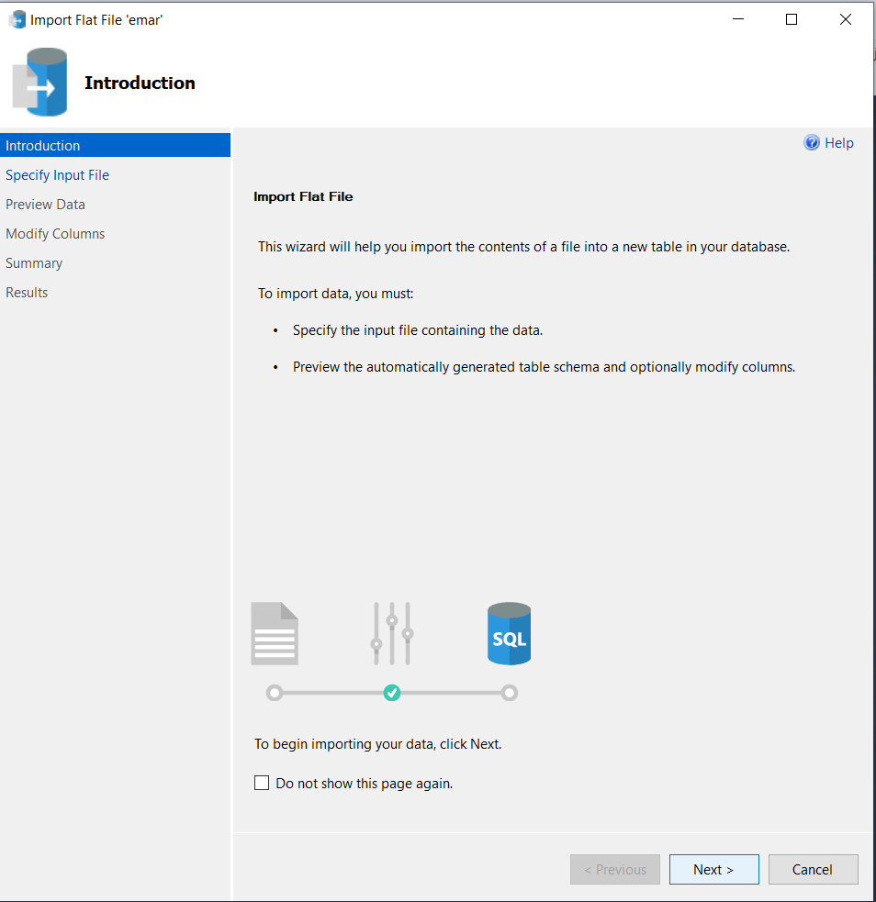
Screen #4
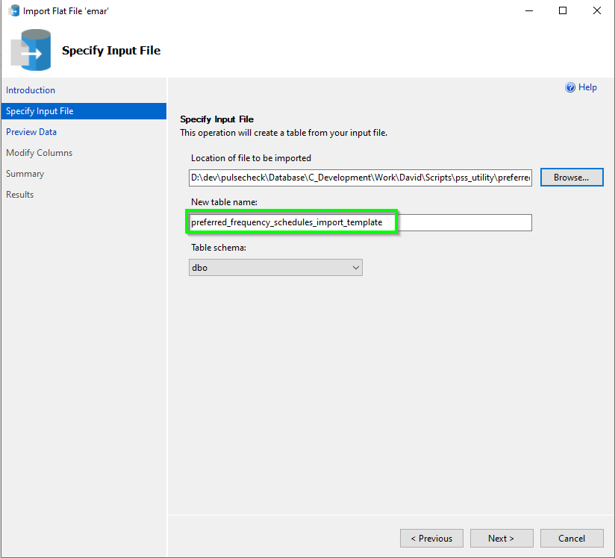
Screen #5
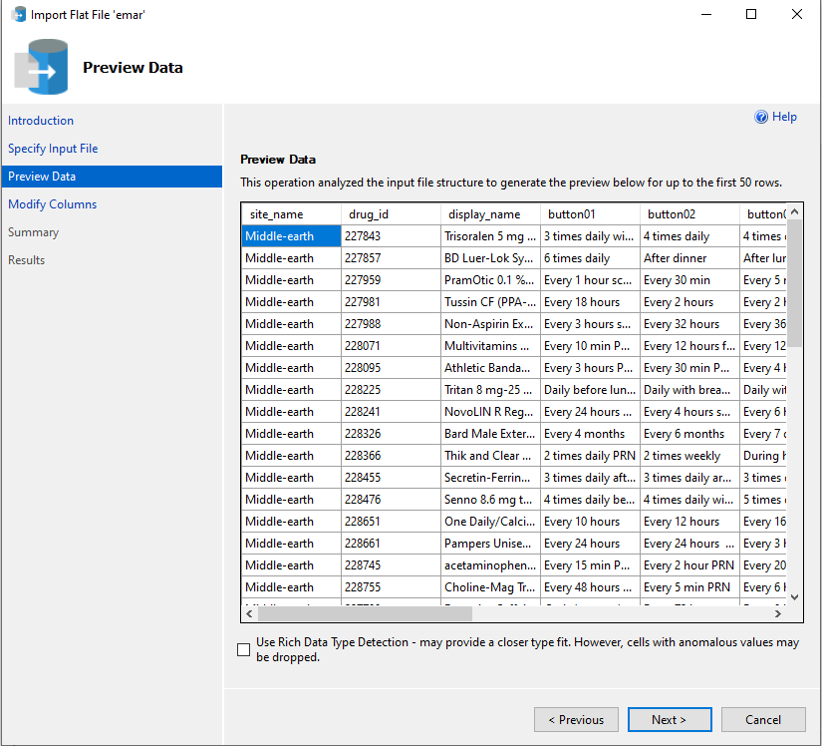
Screen #6
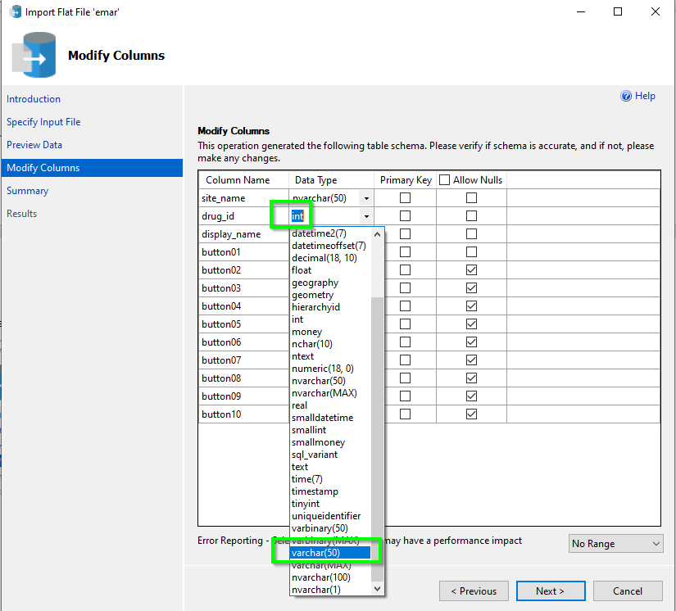
Screen #7
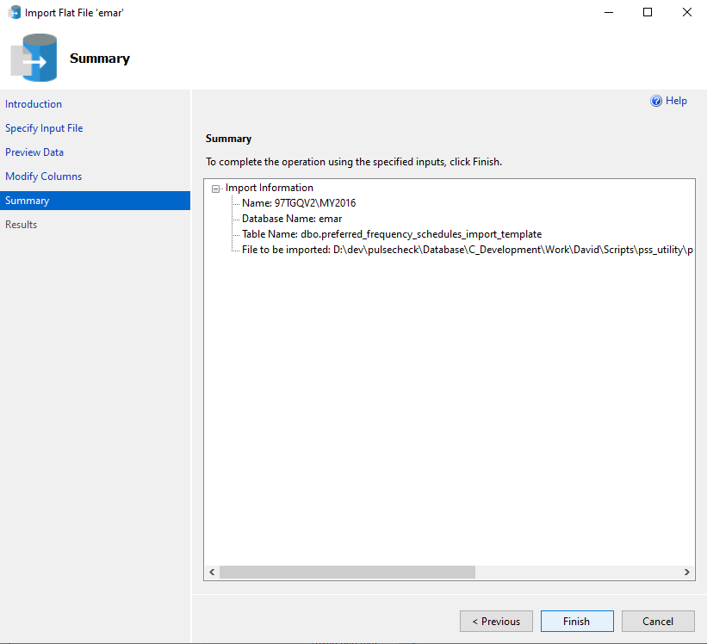
Screen #8
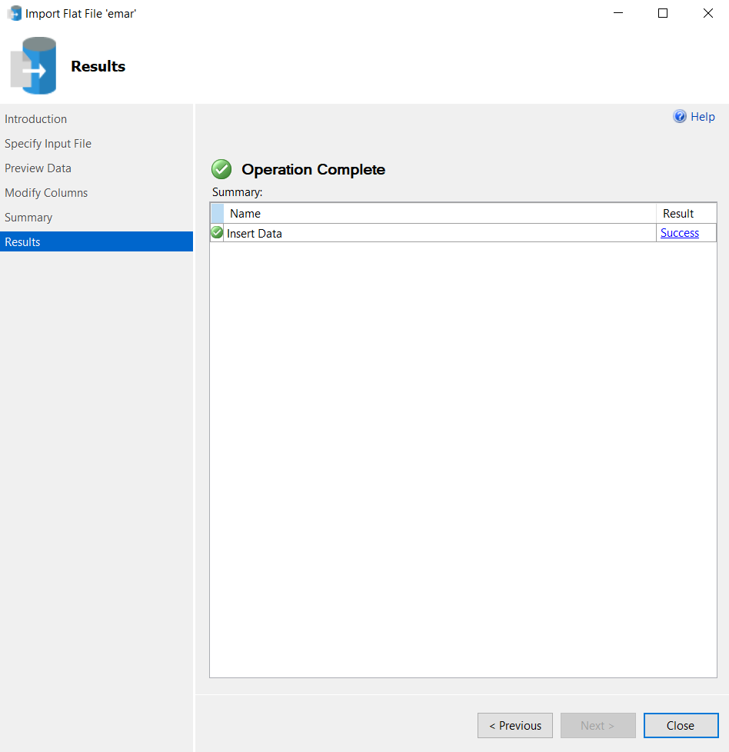
Screen #9
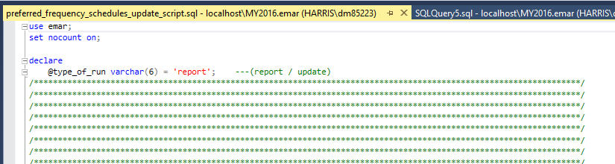

Screen #10
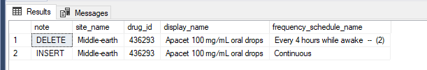

Screen #11
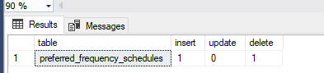
Screen #12
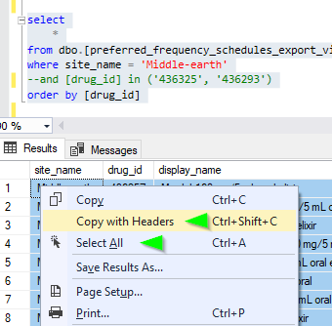

Screen #13
